# Import other necessary packages here

import numpy as np

import **pandas** as pd

* **List of functions to read external data**

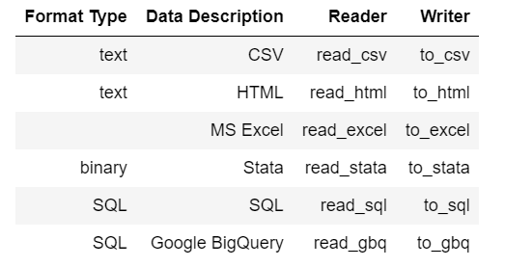

* **Loading data from an Excel File**

# Create an object with the file name in your directory folder 'MyDataPart1.xls' name it excel file

excel_file = 'MyDataPart1.xls'

# If the data is not on your directory use the path

#excel_file = '/Users/DELL/Desktop/Emory/Spring 2021/ECON 320/lab/Week 2/MyDataPart1.xls'

# The data starts from row 11

df = **pd.read_excel**(excel_file, skiprows=10)

# .head() looks at the first five rows in your dataset.

df.head()

* **Loading data in CSV format**

# read csv file into a DataFrame

dataframe_covid = **pd.read_csv**('https://raw.githubusercontent.com/nytimes/covid-19-data/master/us.csv')

# display DataFrame (the first five rows)

print(dataframe_covid.head())

# The method .describe() provides a descriptive summary, similar to summary() in R

dataframe_covid.describe().round()

* **Reading data from a Stata file**

# read data from Stata

bwgth = **pd.read_stata**('bwght2.dta')

# the function **.info()** provides information about the variables in your dataset, number of observations and types.

bwgth.info()